Research AI Task 4

- Introduction
The objective of this task was to predict the price of cars using linear regression. This task consisted of a Car dataset. The dataset contains various numerical and categorical attributes related to car specifications, the goal for us was to implement linear regression from scratch without using machine learning libraries such as scikit learn, and work with basic python libraries.
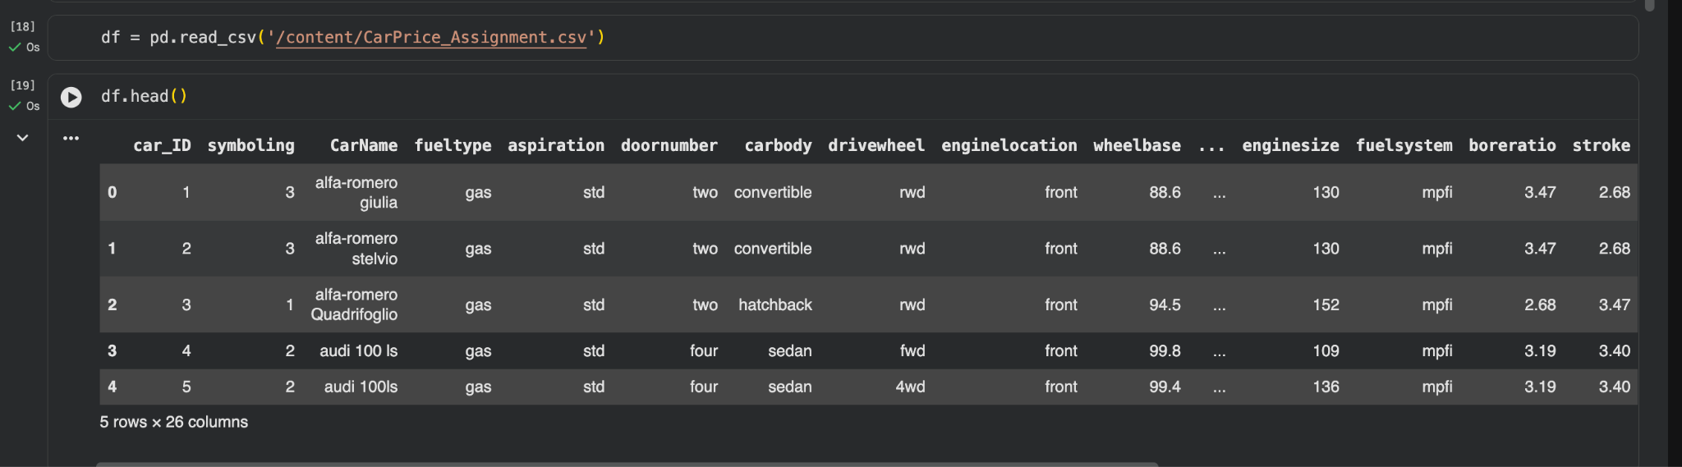

- Dataset Description
The dataset consisted of 205 car records with 26 original features, including both numerical and categorical variables. The target variable was price, which represents the selling price of the car which we must calculate from our data set using linear regression technique. Along with that we were provided with an data dictionary, which helped us to understand the meaning of each attribute.
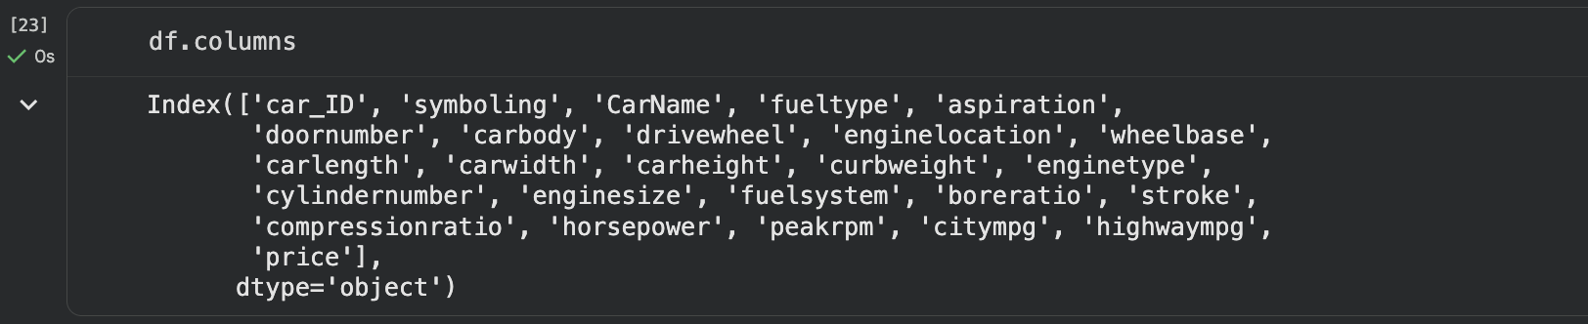
- Model Implementation- Linear Regression
Linear regression was implemented using gradient descent, following the concepts of cost function minimization and parameter updates. The Mean Squared Error (MSE) was used as the cost function. Model parameters were initialized to zero and updated iteratively using the gradient descent algorithm.
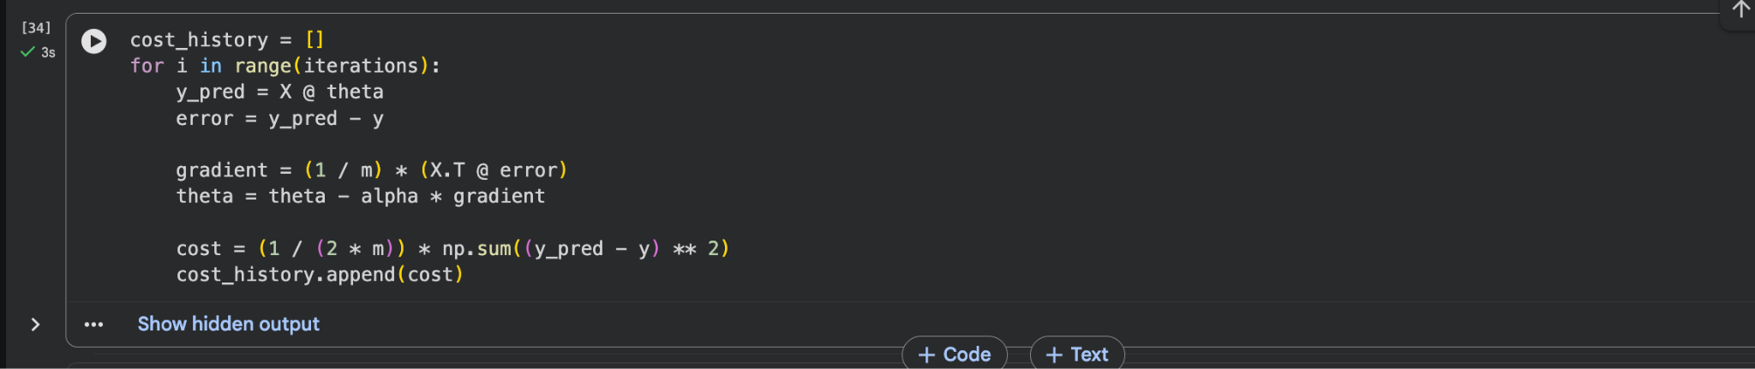
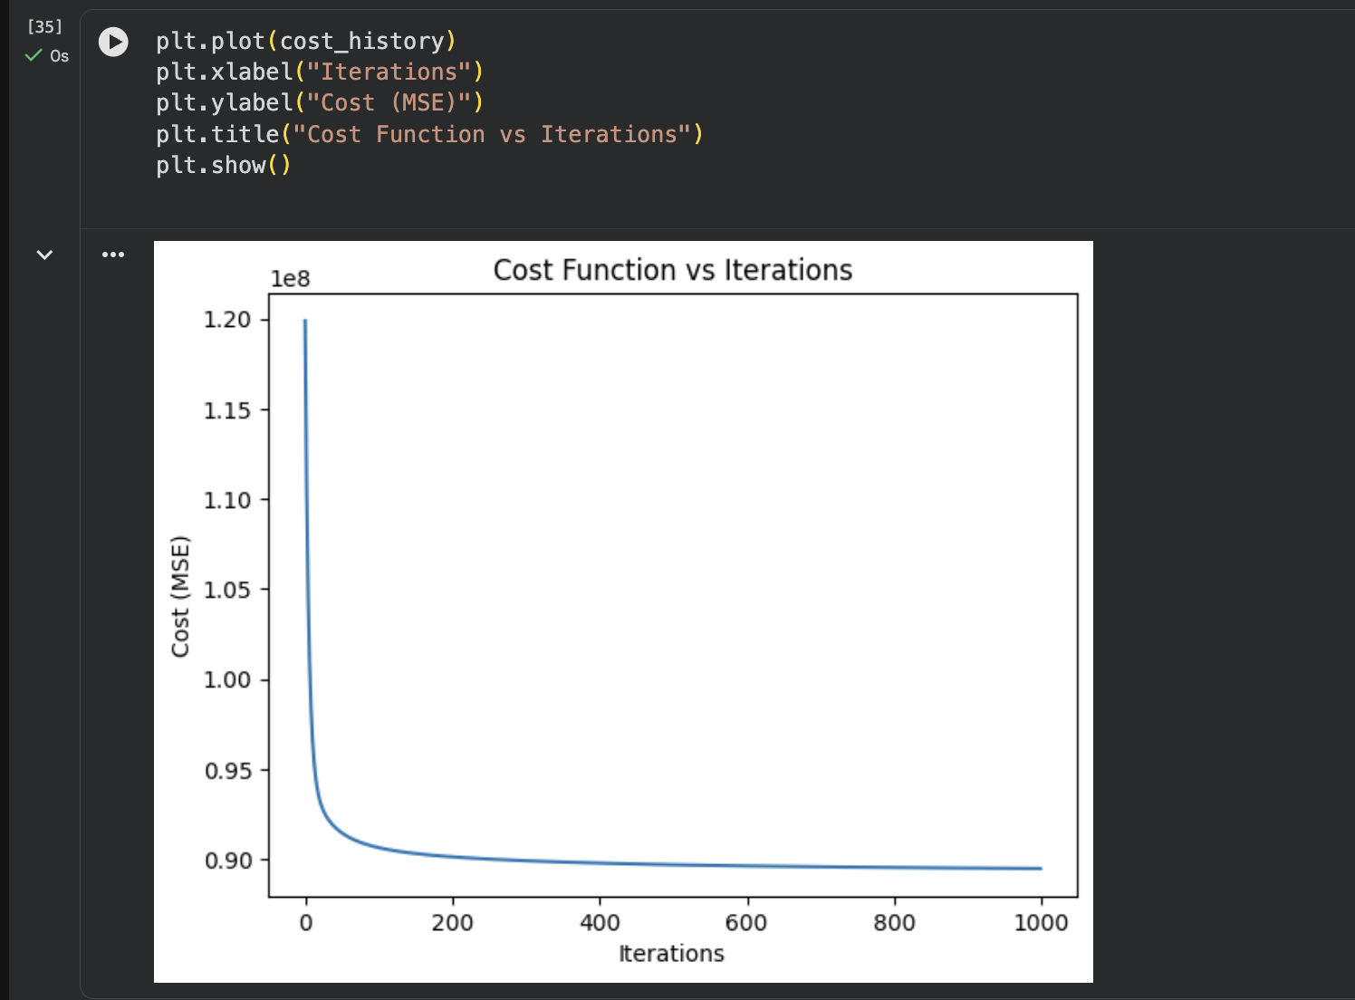
Figure: Decrease in cost function over iterations showing convergence of gradient descent.
- Results and Evaluation
After training the model using gradient descent, predictions were generated for the dataset. The Mean Squared Error was calculated to evaluate model performance. A scatter plot of actual prices versus predicted prices shows a positive correlation, indicating that the model has learned meaningful relationships from the data.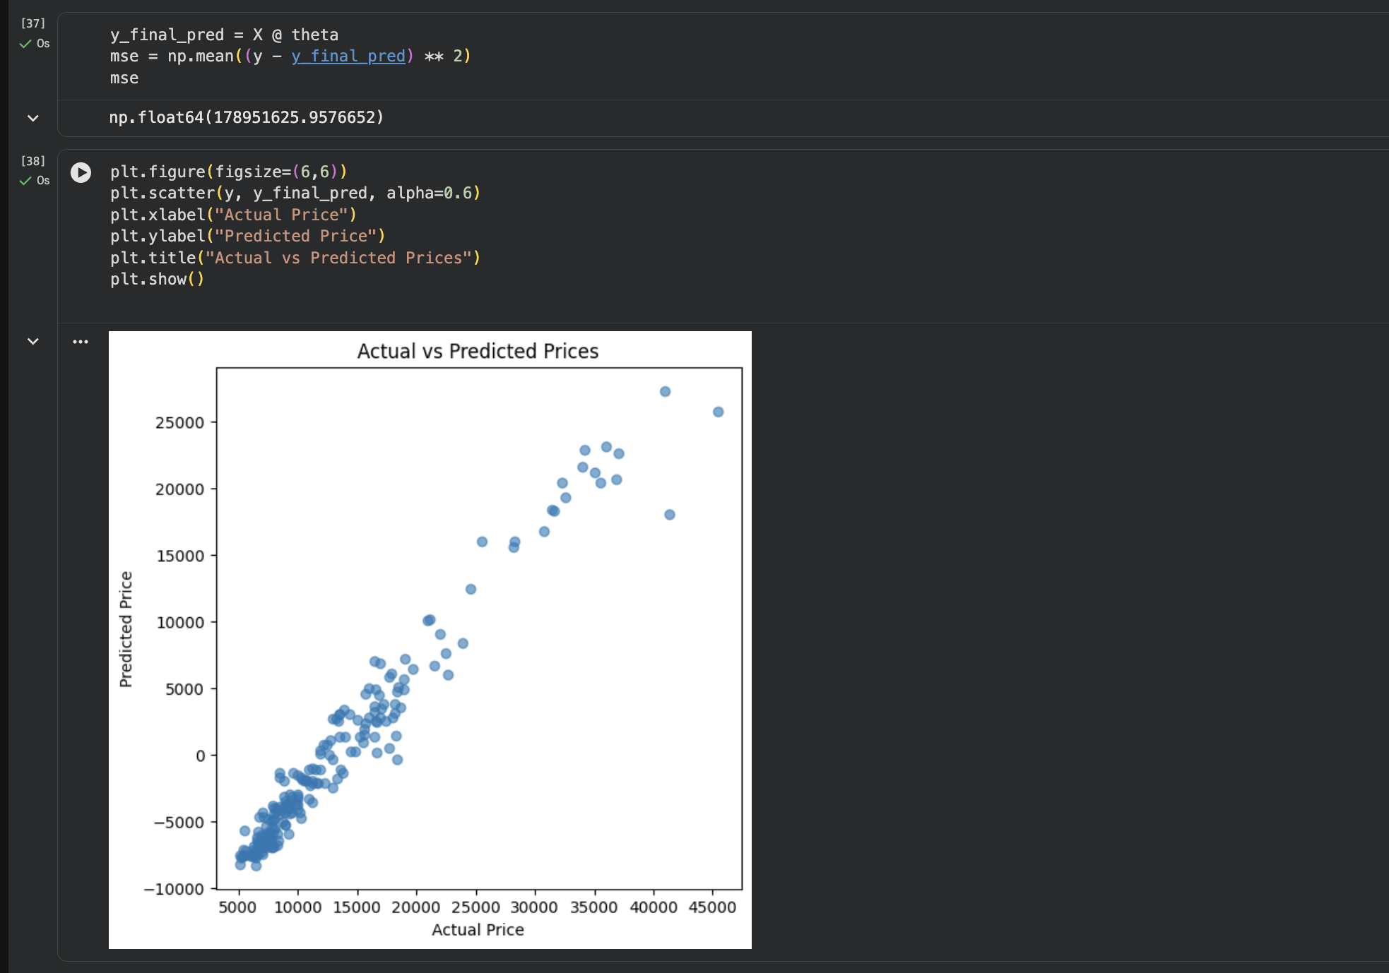
- Conclusion
In this project we used linear regression to implement from scratch to predict car prices. The task reminded me of what I learnt through DAV, aprat from that we learnt new things, which in a way was our introduction into ML, where we dealt with data preprocessing, feature scaling, model training using gradient descent, and evaluation.

https://github.com/Reddevil2007/Cars_price_prediction

